SamStrong continues the final goal of Sam Featherstone (Memorial Class of 2012) to support childhood cancer research. Sam died in January 2013 at the age of 19 after a 3.5 year battle with brain cancer. In support of Sam’s goal, SamStrong gear is available for purchase. All proceeds from the sale of SamStrong gear will fund childhood cancer research at St. Jude Children’s Research Hospital.

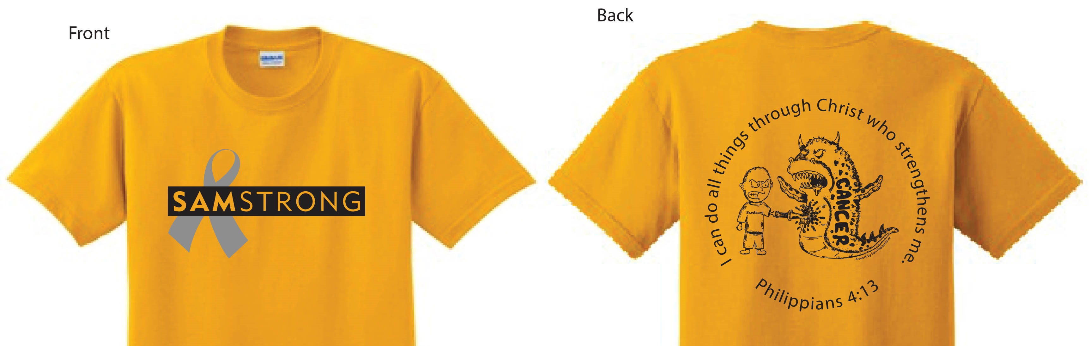

Cost is $10.00 for short sleeve shirts and $15.00 for long sleeve shirts

Name_________________________________________________
Address _______________________________________________
City, State, Zip __________________________________________
Phone _______________ Email ____________________________

Please indicate short or long sleeve
Sizes: Youth: YS________YM_________ YL__________

Adult: AS_________ AM_________ AL__________ AXL__________

SamStrong books ($10) ___ Wristbands ($1.50) ___ Decal Sets ($1.50) ___

Enter quantity of each item you are ordering on line provided and return with your payment (make checks payable to SamStrong). Mail order form and payment to SamStrong, PO Box 252, Newburgh, IN 47629-0252. For more information send us a message by visiting samstrong.org.

THANK YOU for supporting this important cause!

